# Install Magento 2 with docker

1. Download Docker Desktop from [Click Here](https://www.docker.com/products/docker-desktop/).
2. Install docker desktop as administrator.

After installation, please restart the system and open docker after restart

1. Open command prompt
2. Now run command **wsl --update** to update wsl**.**
3. run command **wsl -l -o**

This will give you the list of distribution versions that can be installed.

1. Run **wsl --list --verbose**

This will provide you the wsl integration distribution installed on system.

1. If Ubuntu is not installed run

**wsl --install -d Ubuntu-22.04**

1. Now you can check by **wsl –list --verbose**
2. Now open **Ubuntu-22.04** from search
3. Open **./bashrc** in Ubuntu Terminal

**nano ~/.bashrc**

1. Add below lines at the end of the file

#wsl2 configuration

alias docker=docker.exe

alias docker-compose=docker-compose.exe

alias xbdl= "cd /mnt/c/Users/<username>/Sites/local.xbdl.com"

1. Run **source ~/.bashrc** on linux terminal
2. Open **This PC -> Network -> For Public Network**
   1. **Set Network Discovery: OFF**
   2. **Set File and printer sharing: ON**
3. run command **mkdir -p /mnt/c/Users/<username>/Sites/local.xbdl.com**
4. run command **cd /mnt/c/Users/<username>/Sites/local.xbdl.com**
5. run command **curl -s https://raw.githubusercontent.com/markshust/docker-magento/master/lib/template | bash**
6. if getting any issue after running above commands then remove **.git** from folder **/mnt/c/Users/<username>/Sites/local.xbdl.com**

run command **rm -rf .git/**

1. If getting permission issue on folder then run command **chown -R <system user name>:< system user name> ./local.xbdl.com**
2. Run **git clone** [**https://msftdevicespartners.visualstudio.com/Montebello/_git/Montebello**](https://msftdevicespartners.visualstudio.com/Montebello/_git/Montebello) **src**
3. run command **cp -R ../xbdl/env.php src/app/etc** // file path for env.php
4. run command **bin/start --no-dev**
5. run command **bin/copytocontainer –all**
6. run command **bin/cli bash**
7. run **composer install** command in bash
8. run command **exit** in current bash
9. run command **bin/copyfromcontainer –all**
10. run command **bin/mysql < ../xbdl/stage.sql** //sql file path
11. run command **bin/magento app:config:import**
12. run command **bin/setup-domain local.xbdl.com**
13. run command **bin/restart**
14. run command **bin/cli bash**
15. run command **ls -la ~ | more** (if no **.bashrc** file exit run **touch ~/.bashrc**)
16. run command **curl -o-** [**https://raw.githubusercontent.com/nvm-sh/nvm/v0.39.3/install.sh**](https://raw.githubusercontent.com/nvm-sh/nvm/v0.39.3/install.sh)
17. run command **curl -o- https://raw.githubusercontent.com/nvm-sh/nvm/v0.39.3/install.sh | bash**
18. run command **source ~/.bashrc**
19. run command **nvm list-remote**

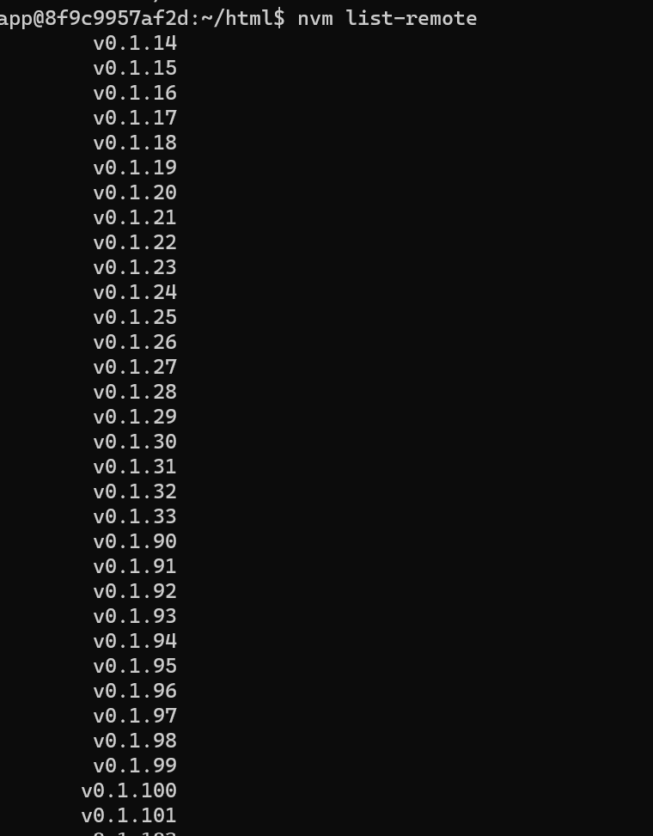

1. run command **nvm install 12.13.0**
2. run command **nvm use 12**
3. run command **npm --prefix vendor/gorilla/m2-frontend-tools/ i**
4. run command **npm --prefix vendor/gorilla/m2-frontend-tools/ run setup**
5. run command **exit**
6. run command **bin/magento s:up**
7. run command **bin/magento s:d:c**
8. run command **bin/magento s:s:d en_US -f** (for US store)
9. run command **bin/cli bash**
10. run command **npm --prefix vendor/gorilla/m2-frontend-tools/ run styles**
11. run command **exit**
12. run command **bin/magento c:f**
13. Open **local.xbdl.com**
14. **Open C:\Windows\System32\drivers\etc\hosts**
15. **Add 127.0.0.1 local.xbdl.com**